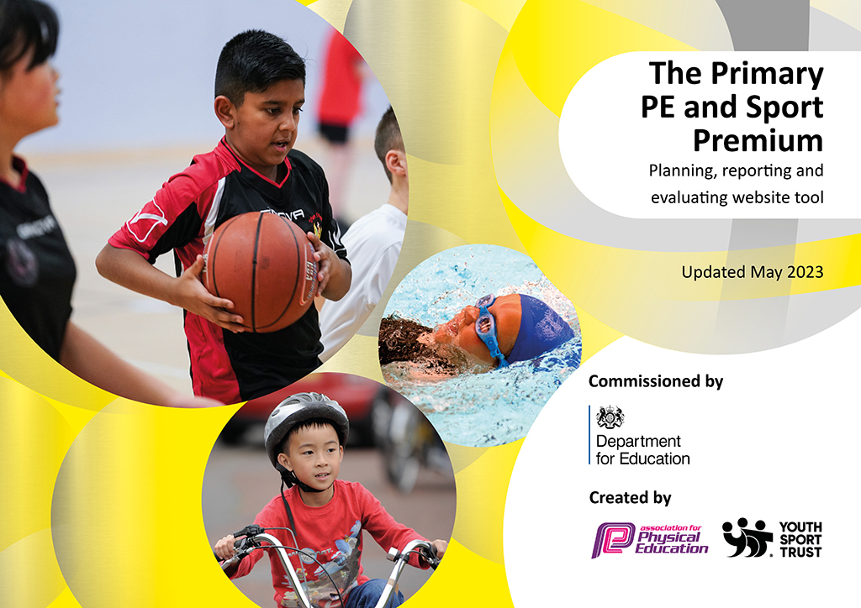
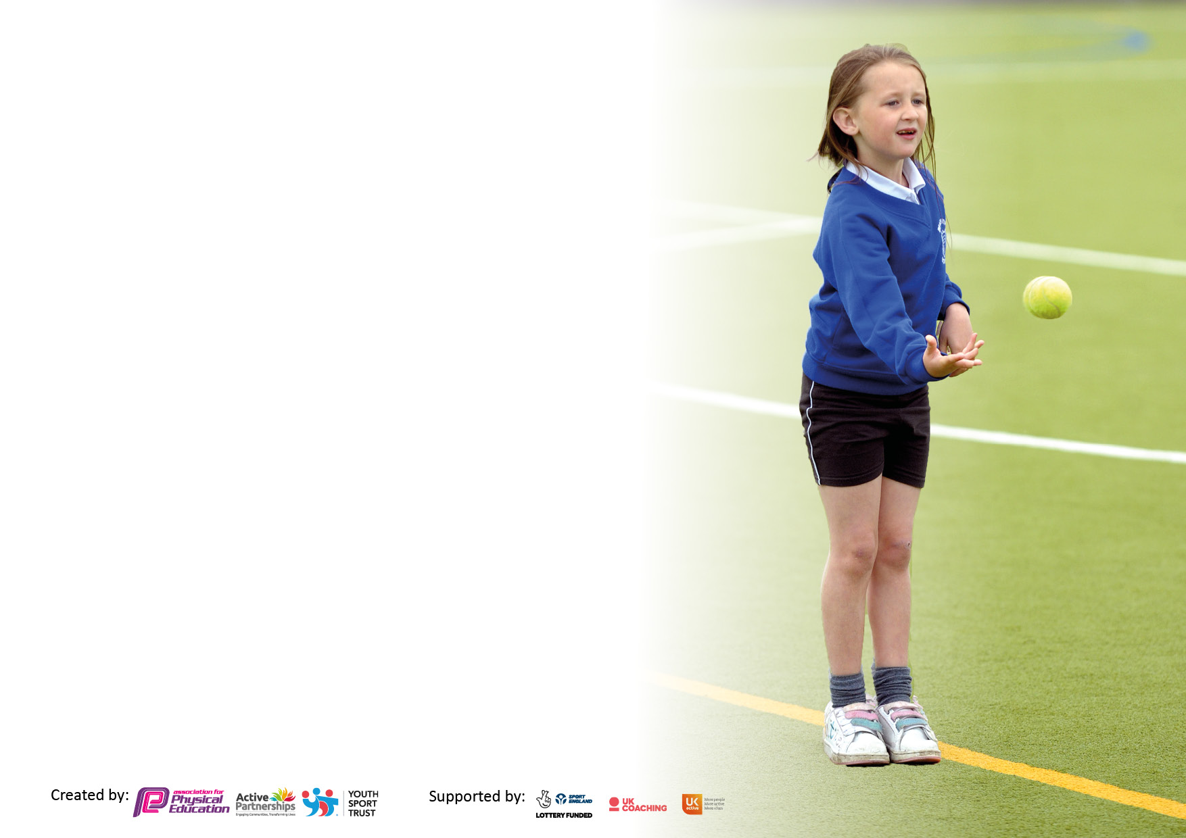

It is important that your grant is used effectively and based on school need. The Education Inspection Framework makes clear there will be a focus on ‘whether leaders and those responsible for governors all understand their respective roles and perform these in a way that enhances the effectiveness of the school’.

Under the Quality of Education Ofsted inspectors consider:
Intent - Curriculum design, coverage and appropriateness
Implementation - Curriculum delivery, Teaching (pedagogy) and Assessment
Impact - Attainment and progress

To assist schools with common transferable language this template has been developed to utilise the same three headings which should make your plans easily transferable between working documents.

Schools must use the funding to make additional and sustainable improvements to the quality of Physical Education, School Sport and Physical Activity (PESSPA) they offer. This means that you should use the Primary PE and sport premium to:

- Develop or add to the PESSPA activities that your school already offer
- Build capacity and capability within the school to ensure that improvements made now will benefit pupils joining the school in future years
- The Primary PE and sport premium should not be used to fund capital spend projects; the school’s budget should fund these.

Please visit gov.uk for the revised DfE guidance including the5keyindicatorsacrosswhichschoolsshoulddemonstrate an improvement. This document will helpyoutoreviewyourprovisionandtoreportyourspend.DfEencouragesschools to use this template as an effective way of meeting the reporting requirements of the Primary PE and Sport Premium.

We recommend you start by reflecting on the impact of current provision and reviewing the previous spend.

Schools are required to publish details of how they spend this funding, including any under-spend from 2021/2022, as well as on the impact it has on pupils’ PE and sport participation and attainment. The funding should be spent by 31st July but the DfE has stated that there will be no clawback of any unspent money so this can be carried forward into 2023/24.

We recommend regularly updating the table and publishing it on your website throughout the year. This evidences your ongoing self-evaluation of how you are using the funding to secure maximum, sustainable impact. Final copy must be posted on your website by the end of the academic year and no later than the 31st July 2023. To see an example of how to complete the table please click HERE.

Details with regard to funding
Please complete the table below.

Total amount carried over from 2021/22 | £
Total amount allocated for 2021/22 | £
How much (if any) do you intend to carry over from this total fund into 2022/23? | £ 7,125
Total amount allocated for 2022/23 | £20,920
Total amount of funding for 2022/23. Ideally should be spent and reported on by 31st July 2023. | £ 12,775
Swimming Data
Please report on your Swimming Data below.

Meeting national curriculum requirements for swimming and water safety.

N.B. Complete this section to your best ability. For example you might have practised safe self-rescue techniques on dry land which you can then transfer to the pool when school swimming restarts.
Due to exceptional circumstances priority should be given to ensuring that pupils can perform safe self rescue even if they do not fully meet the first two requirements of the NC programme of study
What percentage of your current Year 6 cohort swim competently, confidently and proficiently over a distance of at least 25 metres?  N.B. Even though your pupils may swim in another year please report on their attainment on leaving primary school at the end of the summer term 2023.  Please see note above | 90%
What percentage of your current Year 6 cohort use a range of strokes effectively [for example, front crawl, backstroke and breaststroke]?  Please see note above | 63%
What percentage of your current Year 6 cohort perform safe self-rescue in different water-based situations? | 94%
Schools can choose to use the Primary PE and sport premium to provide additional provision for swimming but this must be for activity over and above the national curriculum requirements. Have you used it in this way? | Yes/No

Action Plan and Budget Tracking
Capture your intended annual spend against the 5 key indicators. Clarify the success criteria and evidence of impact that you intend to measure to evaluate for pupils today and for the future.

Academic Year: 2022/23 | Total fund allocated: | Date Updated:
Key indicator 1: The engagement of all pupils in regular physical activity – Chief Medical Officers guidelines recommend that primary school pupils undertake at least 30 minutes of physical activity a day in school |  |  |  | Percentage of total allocation:
 |  |  |  | %
Intent | Implementation |  | Impact
Your school focus should be clear what you want the pupils to know and be able to do and about  what they need to learn and to  consolidate through practice: | Make sure your actions to achieve are linked to your intentions: | Funding allocated: | Evidence of impact: what do pupils now know and what can they now do? What has changed?: | Sustainability and suggested next steps:
Create additional opportunities for physical activity during lunchtimes. | New playgroup equipment purchased. | £1000 | Children engaged in physical activity across lunchtimes. Behaviour is fantastic across all key stages. | Children will be more engaged in positive playtimes and lunchtimes. Playground leaders to be trained from September to make best use of playground equipment.
Key indicator 2: The profile of PESSPA being raised across the school as a tool for whole school improvement |  |  |  | Percentage of total allocation:
 |  |  |  | %
Intent | Implementation |  | Impact
Your school focus should be clear what you want the pupils to know and be able to do and about  what they need to learn and to  consolidate through practice: | Make sure your actions to achieve are linked to your intentions: | Funding allocated: | Evidence of impact: what do pupils now know and what can they now do? What has changed?: | Sustainability and suggested next steps:
 |  | £

Key indicator 3: Increased confidence, knowledge and skills of all staff in teaching PE and sport |  |  |  | Percentage of total allocation:
 |  |  |  | %
Intent | Implementation |  | Impact
Your school focus should be clear | Make sure your actions to | Funding | Evidence of impact: what do | Sustainability and suggested
what you want the pupils to know | achieve are linked to your | allocated: | pupils now know and what | next steps:
and be able to do and about | intentions: |  | can they now do? What has
what they need to learn and to |  |  | changed?:
consolidate through practice:
Continue to support staff confidence, competence and subject knowledge through CPD and improved access to resources. | Re-new license for PE Passport planning and assessment tool.  Continue to audit and replenish PE equipment, using the sports leaders and staff to identify need for new equipment.  Manchester City to deliver curriculum sessions 1 day per week in EYFS/Y1-Y6 to increase staff Knowledge & Confidence within PE. | £300 (PE Passport)  £1,735  £8500 | License for PE Passport has been renewed. This allows teachers in all years to have access to a range of planning that link directly from the curriculum and aims to improve children's physical literacy from EYFS to Year 6. Incredibly useful tool during OFSTED inspection to show progression of curriculum.  New Gym mats were required after safety inspections.  Teachers were asked prior to renewal if they felt the sessions benefitted their own knowledge and confidence. All teachers said it did. SLT also supportive of continued partnership. | Extend knowledge and understanding by continuing to improve staff confidence using the APP in order to achieve new ‘End Goals’ on the PE Curriculum.  Teachers more confident to teach gymnastics safely.  Subject leader to have time to team teach and observe teachers to see the benefit of observing and team teaching in MCFC sessions.
Key indicator 4: Broader experience of a range of sports and activities offered to all pupils |  |  |  | Percentage of total allocation:
Intent | Implementation |  | Impact
Your school focus should be clear | Make sure your actions to | Funding | Evidence of impact: what do | Sustainability and suggested
what you want the pupils to know | achieve are linked to your | allocated: | pupils now know and what | next steps:
and be able to do and about | intentions: |  | can they now do? What has
what they need to learn and to |  |  | changed?:
consolidate through practice:
 |  | £

Key indicator 5: Increased participation in competitive sport |  |  |  | Percentage of total allocation:
 |  |  |  | %
Intent | Implementation |  | Impact
Your school focus should be clear | Make sure your actions to | Funding | Evidence of impact: what do | Sustainability and suggested
what you want the pupils to know | achieve are linked to your | allocated: | pupils now know and what | next steps:
and be able to do and about | intentions: |  | can they now do? What has
what they need to learn and to |  |  | changed?:
consolidate through practice:
 | Manchester PE association fees.  Sports Day Medals (EYFS) | £1140  £100 | Children able to access a range of competition throughout the year.  EYFS children loved their sports day and the medal will begin to inspire them to see competitive sport as something they enjoy. | To access a greater number of Excel competitions alongside the inspire to offer a greater number of children the opportunity to compete.

Signed off by
Head Teacher: | A.Marchant
Date: | 21.7.23
Subject Leader: | P. Eccles
Date: | 21.7.23
Governor:
Date:

